# Increasing Accessibility to the Casual Market Continued

This document continues from the issues and challenges outlined in the previous ‘Increasing Accessibility to the Casual Market’ document. Given the tight timing limitations with the previous document, this updated document intends to further discuss the challenges previously presented, making reference to contemporary game design theory.

## Establishing the Main Issue

As stated in page 6 of the brief “Casual Users don’t have the dexterity of gamers”. The Cambridge Dictionary defines dexterity as “*the ability to perform a difficult action quickly and skilfully with the hands,* ***or the ability to think quickly and effectively***”. This definition unequivocally highlights a major issue with our main twitch mechanic – it requires a level of quick reaction that may not be present in all casual users.

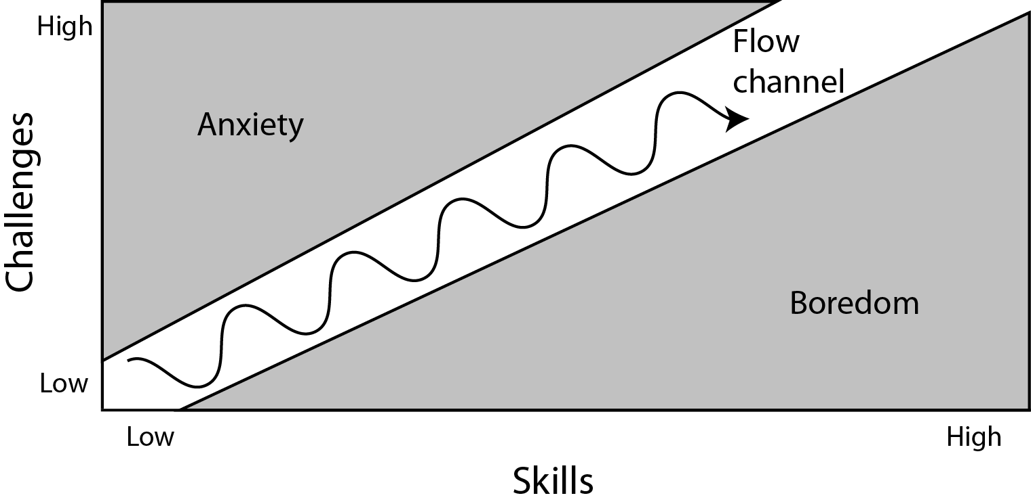Testing a skill that is clearly weaker in the casual audience than with experienced gamers runs the risk of overburdening new players with too much of a challenge. If this occurs, the player never enters a state of flow, as they cannot escape the “anxiety” zone (see figure 1). In this scenario, the player will simply stop playing as they find the difficulty of the game too daunting.

Figure - A diagram illustrating Csíkszentmihályi's Flow Theory

## A Simple Solution

Theoretically, in order to address the issue of oppressive difficulty (and as suggested originally, at the start of the design process) a dynamic skill determining algorithm could be implemented to identify the skill level of each player and adjust the difficulty of the game appropriately. This difficulty adjustment could take many forms. For example, the timer bar could move at a slower rate, or a heavier weighting could be placed on each hit.

Careful considerations would have to be made in regards to the implementation of this, however, as if either player identified that intentionally mistiming hits leads to an advantage, a dominant strategy would be formed. Introducing this feature would require immense amounts of playtesting to insure invisibility.

## Why isn’t this Already in the Game?

Whilst, as previously alluded to, we intended for this to be included in our game, we encountered numerous issues in regards to the symmetry aspect of the brief. After further discussion with lecturers, it is now clear that the game does not need to be perfectly symmetrical, rather symmetrical in the sense that both players are presented with the same opportunity to win the game and that any bias towards one player ‘evens-out’ in the long run.

As such, the difficulty adjusting algorithm is comparable to stabilisers on a bicycle. As players first ‘learn the ropes’, the algorithm adjusts the game to make it more enjoyable for players to learn the game’s main mechanic. As they progress further through the ‘Learn, Practice, Master’ loop, the game then scales in difficulty, keeping them in a state of flow.

Availability of this algorithm needs to be present and non-discriminatory for both players (i.e. the opportunity for advantage is equal for both players, providing they are both of a low enough skill level). If two ‘bad’ players meet, the algorithm is making the game easier for the both of them; if one ‘good’ player and one ‘bad’ player meet, the algorithm is making the game easier for only the ‘bad’ player; if two ‘good’ players meet, the algorithm is does nothing at the game plays at its standard difficulty.

## Chance

Schell highlights the importance of chance stating “chance is an essential part of a fun game because chance means uncertainty, and uncertainty means surprises”. Salen and Zimmerman further agree with this synopsis, stating that chance “[creates the] uncertainty of knowing who will win and the struggle to finish first”.

Moreover, Lennart Nacke describes in his academic blog titled ‘Chance and Skill in Game Design’ (available [here](http://www.acagamic.com/courses/infr1330-2014/chance-and-skill-in-game-design/)) the various reasons for using chance as an explicit mechanic. Of these reasons, the most relevant to us is as follows; “the game designer wants the gameplay to be balanced and competitive for all different kinds of players”. Given the large demographical differences within the wider ‘casual’ market, implementing higher variance of chance is an additional way of giving less skilled players a good chance of winning and feeling involved.

Chance can be implemented in numerous different ways, for example randomised weighting could be added to each threshold of the timer bar. In this example, if a player scores a ‘good’ hit, the hit could register anywhere from 1.2 to 1.7, determined randomly – the wider this variance, the more chaotic the game will seem.

This has to balanced carefully, however, as players will quickly feel disconcerted if the worse player regularly wins purely because of luck. Moreover, this can also have implications on the ‘learn, practice, master’ loop – the more a game relies upon random generation, the less a player can do to hone their skills and consistently improve their results.

## Types of Skill

In Jesse Schell’s ‘The Art of Game Design a Book of Lenses’, he categorises skills into 3 main types; Physical, Mental and Social. In regards to our main twitch mechanic, Schell clearly places the skill of dexterity into the first category of physical skill, alongside “strength, […] coordination and physical endurance”.

Consequently, a further measure to increase accessibility to the casual market would be to investigate alternative, complementary mechanics from one of Schell’s alternate brackets; mental skills or social skills.

## Mental Skills

Schell describes mental skills as “the skills of memory, observation and puzzle solving”. A mechanic revolving around a player’s memory and observation skills has already been discussed within our group previously.

This mechanic would revolve an additional phase before the main twitch mechanic in which players would be bombarded with information overload (in similar vein to ‘Where’s Wally?’) and required to identify a key piece of information (the secret code to a spaceship’s cockpit, for example). Players are then required to hold this information in short-term memory, as the game asks for it later. If the player remembers this key information well, the twitch mechanic is made considerably easier (either the timing windows are extended or the bar slows down).

## Social Skills

Schell describes social skills as “[the skills of] reading an opponent (guessing what he is thinking), fooling an opponent and coordinating with teammates”.

As our game is a two-player game, incorporating coordination with teammates will not work as each player is playing alone against their opponent. Moreover, the aspect of reading and/or fooling and opponent (as would be seen in a game such as poker, for example) is not present as both players are given perfect knowledge about the current game state.